Department of Computer Science and Engineering

Assignment Questions

Course Code & Name: CSA0615 –Design and Analysis of Algorithms
Particular | Details
Department: | AI&DS
Programme: | BTech
Course Code & Course Name | CSA0621 - Design and Analysis of Algorithms
Academic Year / Batch | 2nd Year
Faculty Name | Dr G Nagarajan
Assignment Title | Development of an Efficient Algorithmic Solution for Large-Scale Data Processing
Date of Issue | 02/09/2026
Date of Submission | 03/09/2026
Maximum Marks | 100
Course Outcome(s) – CO | CO1: Analyse the efficiency of recursive and non-recursive algorithms using asymptotic notations (Big-O, Ω, Θ) and complexity-analysis methods such as the master theorem, substitution, and iteration.  CO2: Apply brute-force techniques such as sorting and searching to solve computational problems.  CO3: Apply divide-and-conquer techniques to design efficient algorithmic solutions.
Bloom's Taxonomy Level | L4 – Analyse; L5 – Evaluate; L6 – Create
SDG Mapping (SDG 1-17) | SDG 9 – Industry, Innovation and Infrastructure
Industry / Societal Relevance | Smart Infrastructure Planning and Geospatial Data Optimization

A. Assignment Problem / Challenge
The assignment should preferably require students to:

- Apply course concepts rather than reproduce theory.
- Identify and analyze the problem.
- Consider requirements and constraints.
- Develop or compare alternative solutions where appropriate.
- Use relevant modern engineering/computing/design tools.Interpret results.
- Make and justify engineering decisions.
- Consider appropriate technical, economic, environmental, societal, ethical, safety or sustainability factors wherever relevant.

B. Problem Statement
An infrastructure-planning agency maintains a large, publicly available geospatial dataset of facility locations — for example, the OpenFlights airports dataset (~40,000 points) or a cell-tower / weather-station dataset containing 10⁴–10⁶ coordinate records. To detect redundant or dangerously close facilities and to optimise service coverage, the agency must identify the closest pair of locations — the two points separated by the minimum Euclidean distance in the dataset.
Develop, implement, and evaluate a solution to this Closest-Pair-of-Points problem. Implement (i) a Brute-Force algorithm that evaluates all n(n−1)/2 pairs, of order O(n²), and (ii) a Divide-and-Conquer algorithm that recursively partitions the point set about the median x-coordinate and merges across the dividing strip, of order O(n log n) ; then develop an optimised hybrid that reverts to brute force below a threshold sub-problem size. Analyse the theoretical efficiency of each approach using Big-O, Ω, and Θ notations, solving the recurrence T(n) = 2T(n/2) + O(n) by the master theorem. Experimentally evaluate all three algorithms on the chosen dataset across increasing input sizes (for example, 10³ to 10⁶ points), measuring execution time, number of distance computations/comparisons, memory utilisation, and scalability. Based on the theoretical and experimental results, optimise the solution and justify why the proposed hybrid is most suitable for large-scale infrastructure data — reflecting Bloom’s Levels 4–6 (Analyse, Evaluate, Create) and contributing to SDG 9 (Industry, Innovation and Infrastructure).

C. Requirements and Constraints
Use a publicly available real-world coordinate dataset with enough records to test multiple input sizes (10³–10⁶ points). All three algorithms (brute force, divide-and-conquer, hybrid) must be run in the same computational environment for a fair comparison, on identical inputs. Report both empirical timings and operation counts, and clearly document the threshold chosen for the hybrid, along with all assumptions and limitations.

D. Student Work

- Problem Statement and Problem Formulation
1.1 Problem Statement
A large geospatial dataset contains the coordinates of facilities such as airports, cell towers, and weather stations. The agency needs to identify the closest pair of locations to detect redundant or dangerously close facilities and improve service coverage. For points, the Brute-Force method checks all possible pairs, resulting in time complexity. This becomes inefficient as the dataset grows to thousands or millions of points. Therefore, Divide-and-Conquer and an optimized Hybrid algorithm are developed to reduce computation time and improve scalability. The performance of all three approaches is evaluated using execution time, distance comparisons, memory usage, and scalability.

1.2 Problem Formulation
Let the input dataset be:
P={p1​,p2​,p3​,…,pn​}
where each point is represented by a two-dimensional coordinate:
pi​=(xi​,yi​)
Thus, the required output is:
- The first point (x1​,y1​)
- The second point (x2​,y2​)
- The minimum distance between the two points
- Number of distance calculations/comparisons
- Execution time for the selected algorithm

1.3 Computational Challenge
The major challenge is the large number of pairwise comparisons. The Brute-Force approach requires:
n(n-1)/2
distance calculations.
For example:
Number of Points | Number of Pairs
1,000 | 499,500
10,000 | 49,995,000
100,000 | 4,999,950,000
1,000,000 | 499,999,500,000

- Objective and Expected Outcomes
2.1 Objectives
- To understand and formulate the Closest-Pair-of-Points Problem for large-scale geospatial datasets.
- To implement a Brute-Force algorithm with O(n2) time complexity.
- To implement a Divide-and-Conquer algorithm with O(nlogn) time complexity.
- To develop a Hybrid algorithm that combines Divide-and-Conquer and Brute Force.
- To analyze the algorithms using Big-O, Ω, and Θ asymptotic notations.
- To solve and explain the recurrence T(n)=2T(n/2)+O(n) using the Master Theorem.
- To compare the algorithms using execution time and operation counts.
- To evaluate memory utilization and scalability for increasing dataset sizes.
- To determine a suitable threshold at which the Hybrid algorithm should switch to Brute Force.
- To justify the final algorithm based on theoretical and experimental results.

2.2 Expected Outcomes
- A working implementation of all three algorithms.
- Correct identification of the closest pair for the given dataset.
- Demonstration that Brute Force becomes increasingly expensive as n grows.
- Demonstration of the improved scalability of Divide-and-Conquer.
- Identification of a practical Hybrid threshold.
- Experimental evidence through execution times, operation counts, tables, and graphs.
- A justified final algorithm suitable for large-scale geospatial infrastructure data.
- Understanding of the practical trade-offs between simplicity, execution speed, memory usage, and scalability.

- Requirements, Constraints and Assumptions
3.1 Requirements
- Use a publicly available real-world coordinate dataset containing a sufficiently large number of records.
- Implement three algorithms:
  - Brute Force
  - Divide-and-Conquer
  - Hybrid approach
- Test the algorithms using increasing input sizes, approximately from to points.
- Run all algorithms in the same computational environment using identical inputs.
- Measure execution time, distance computations/comparisons, memory utilization, and scalability.
- Document the threshold value selected for the Hybrid algorithm.
- Present experimental results and compare the performance of all three approaches.

3.2 Constraints
- Brute Force has O(n2) time complexity and becomes impractical for very large datasets.
- Large datasets require significant processing time and memory.
- All algorithms must operate on the same input data for a fair comparison.
- The Hybrid algorithm requires a suitable threshold for switching from Divide-and-Conquer to Brute Force.
- Experimental results may depend on the computational environment and available resources.

3.3 Assumptions
- Each location is represented using a two-dimensional coordinate (x,y) .
- Euclidean distance is used to measure the distance between locations.
- The input dataset contains valid coordinate records.
- The same dataset and computational environment are used for comparing all three algorithms.
- The closest pair is determined by the minimum distance between any two distinct points.
- The dataset is sufficiently large to demonstrate differences in algorithmic performance.

- Application of Relevant Course Knowledge

Asymptotic Analysis: Big-O, Ω, and Θ notations are used to analyze and compare the efficiency of the Brute-Force, Divide-and-Conquer, and Hybrid algorithms.
Brute-Force Technique: The Brute-Force approach is applied by checking every possible pair of points. It performs distance calculations and has O(n²) time complexity.
Divide-and-Conquer: The dataset is recursively divided around the median x-coordinate, and the closest pair is determined by solving smaller sub-problems and checking the dividing strip. This provides O(n log n) time complexity.
Master Theorem: The recurrence T(n)=2T(n/2)+O(n) is analyzed using the Master Theorem to establish the O(n log n) efficiency of the Divide-and-Conquer solution.
Algorithm Optimization: A Hybrid algorithm is developed by combining Divide-and-Conquer with Brute Force. For smaller sub-problems, Brute Force is used to reduce recursive overhead, while Divide-and-Conquer handles larger datasets.
Performance Evaluation: Course knowledge is applied to experimentally compare execution time, distance calculations/comparisons, memory utilization, and scalability using increasing dataset sizes.

- Design / Proposed Solution / Methodology
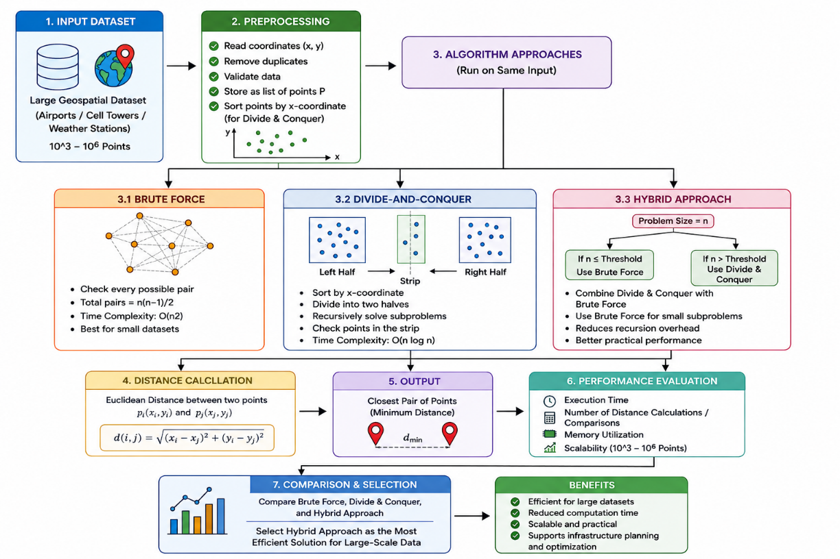
- Pseudocode /Algorithm
ALGORITHM INTELLIGENT_CLOSEST_PAIR_ANALYZER

INPUT:
Dataset P containing n coordinate points
Hybrid threshold T

OUTPUT:
Closest pair of points
Minimum distance
Execution time, comparisons, distance computations, memory usage

BEGIN

Load or generate n coordinate points

FOR each selected algorithm DO

Start timer and memory measurement

IF algorithm = BRUTE FORCE THEN

minDistance ← ∞

FOR i ← 1 TO n-1 DO
FOR j ← i+1 TO n DO

d ← EuclideanDistance(P[i], P[j])

Increment distance computation counter
Increment comparison counter

IF d < minDistance THEN
minDistance ← d
closestPair ← (P[i], P[j])
END IF

END FOR
END FOR

ELSE

Sort P by X-coordinate
Sort P by Y-coordinate

DEFINE Closest(Px, Py)

IF size(Px) ≤ T THEN
RETURN BruteForce(Px)
END IF

Divide Px into Left and Right halves
Divide Py into LeftY and RightY

LeftResult ← Closest(Left, LeftY)
RightResult ← Closest(Right, RightY)

Select the smaller distance
δ ← minimum of LeftResult and RightResult

Create a strip containing points
within δ of the dividing line

FOR each relevant pair of points in strip DO

Calculate their distance
Increment counters

IF distance < δ THEN
δ ← distance
closestPair ← current pair
END IF

END FOR

RETURN closestPair, δ

END DEFINE

result ← Closest(Px, Py)

END IF

Stop timer and memory measurement

Record:
Execution Time
Distance Computations
Comparisons
Memory Usage
Closest Pair
Minimum Distance

END FOR

Display closest pair on GUI

Display performance results

Generate execution-time comparison graph

END
- Source Code and Environment / Tools Used

Programming Language: Python was used to implement the Brute-Force, Divide-and-Conquer, and Hybrid algorithms
Development Environment: Jupyter Notebook was used for coding, execution, testing, and performance evaluation
Pandas: Used for loading, processing, and managing the geospatial coordinate dataset.
Matplotlib: Used to generate graphs and visualize execution-time and performance comparisons.
Dataset: The publicly available OpenFlights airport dataset was used for geospatial coordinate analysis.
Algorithm Implementation: Source code includes the three approaches—Brute Force, Divide-and-Conquer, and Hybrid—and measures their execution time and distance calculations.

- Test Cases and Expected Results

Test Case | Input Size | Expected Result
TC1 | 100 points | All three algorithms find the same closest pair.
TC2 | 1,000 points | Correct closest pair with performance measurements.
TC3 | 10,000 points | Divide-and-Conquer and Hybrid perform better than Brute Force.
TC4 | 100,000+ points | Hybrid and Divide-and-Conquer show better scalability.
TC5 | Different input sizes | Execution time and distance calculations are recorded.

- Execution Screenshots

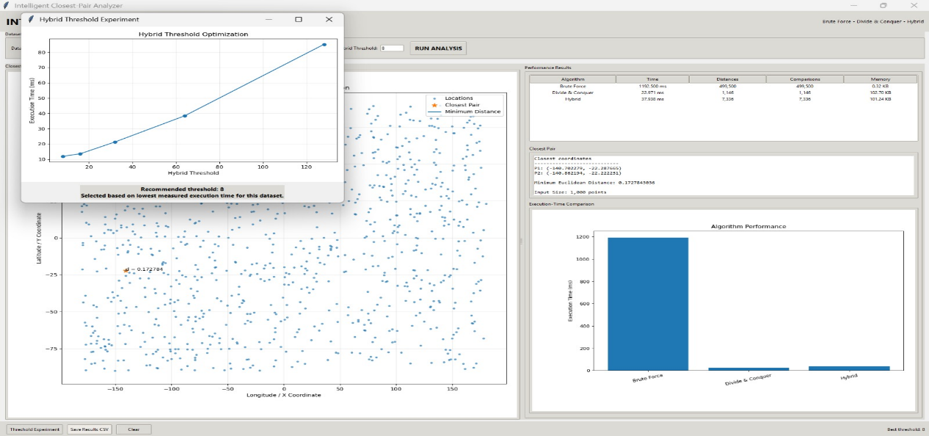

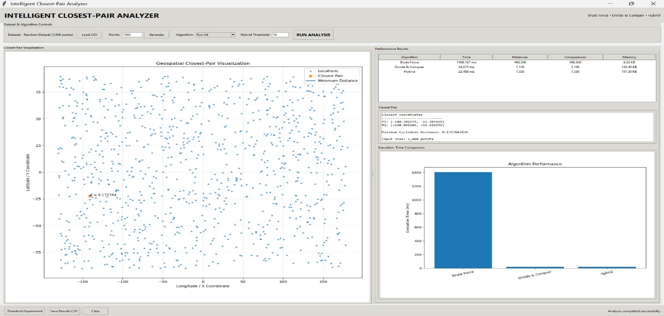
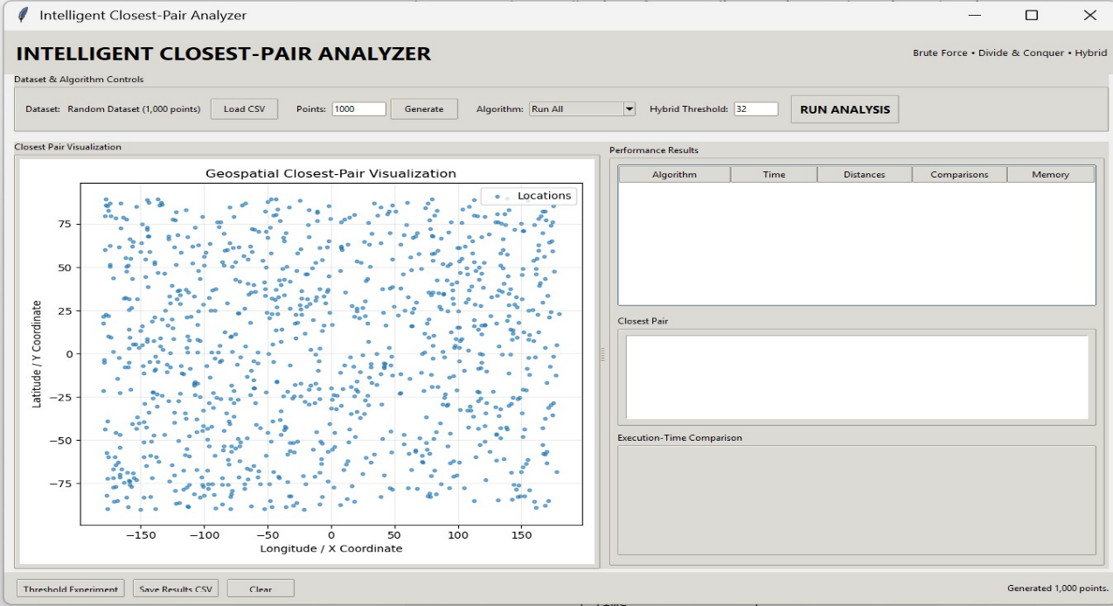

- Results and Validation
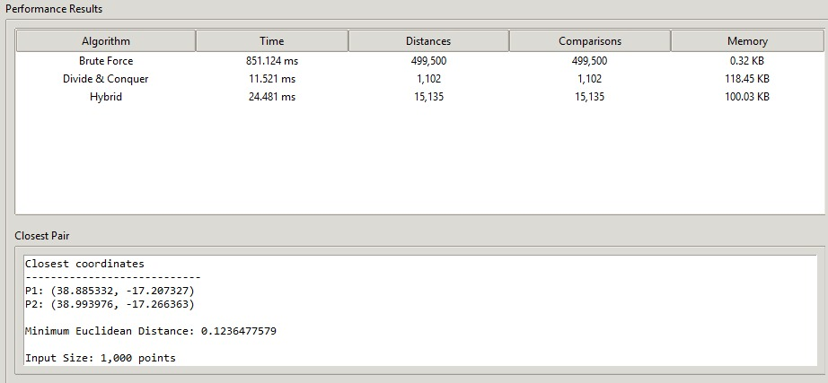

- Analysis, Comparison

11.1 Analysis
The Brute-Force algorithm is simple and easy to implement, but its O(n²) time complexity makes it inefficient for large datasets. The Divide-and-Conquer algorithm reduces the complexity to O(n log n) by dividing the dataset into smaller sub-problems. The Hybrid algorithm combines both approaches to improve practical performance.

11.2 Comparison
Feature | Brute Force | Divide-and-Conquer | Hybrid
Time Complexity | O(n²) | O(n log n) | O(n log n)
Implementation | Simple | More complex | More complex
Large Dataset Performance | Poor | Good | Very Good
Recursive Overhead | None | Higher | Reduced
Small Sub-problems | Efficient enough | May have overhead | Efficient
Scalability | Low | High | High

- Broader Considerations / SDG Relevance

The proposed Closest-Pair-of-Points solution is relevant to SDG 9 – Industry, Innovation and Infrastructure, as it provides an efficient approach for processing large-scale geospatial data used in infrastructure planning.

- Efficient Infrastructure Planning: Identifies facilities that are very close to each other, helping detect redundancy and improve facility placement.
- Improved Resource Utilization: Supports better allocation of infrastructure resources by identifying locations that may require optimization or relocation.
- Scalability: The Divide-and-Conquer and Hybrid algorithms can handle large datasets more efficiently than the Brute-Force approach.
- Smart Infrastructure Development: The solution can be useful for applications involving airports, cell towers, weather stations, and other geographically distributed facilities.
- Faster Decision-Making: Reduced computation time allows infrastructure planners to analyze large datasets and make decisions more quickly.
- Innovation in Data Processing: The Hybrid approach combines the strengths of Divide-and-Conquer and Brute Force, providing better practical performance for different input sizes.
- Sustainable Infrastructure: Efficient computational methods can contribute to cost-effective and data-driven infrastructure development.

- Individual Contribution of Group Members

M. Ranjith Kumar Reddy (192524172)
Worked on problem identification, problem formulation, requirements, and the implementation of the Brute-Force algorithm

Lella Thannveer Reddy (192524293)
Designed and implemented the Divide-and-Conquer algorithm and analyzed its time complexity using asymptotic analysis and the Master Theorem.

M. Gowtham Kumar (192525163)
Developed the Hybrid algorithm, selected the threshold value, and performed testing, performance evaluation, and comparison of all three algorithms.

- References, including datasets, software/tools and other sources used, wherever applicable

- OpenFlights Dataset – Publicly available airport location dataset used for geospatial coordinate analysis.
- Cormen, T. H., Leiserson, C. E., Rivest, R. L., & Stein, C. – Introduction to Algorithms, MIT Press. Used for understanding Divide-and-Conquer, asymptotic analysis, and the Closest-Pair algorithm.
- Python Documentation – Used as a reference for programming and implementation of the algorithms.
- Python / Jupyter Notebook – Used for algorithm implementation, execution, testing, and performance evaluation.
- Matplotlib – Used for generating graphs and visualizing execution-time and performance comparisons.
- Pandas – Used for loading, processing, and managing the geospatial dataset.

- One-Page Individual Reflection

M. Ranjith Kumar Reddy (192524172)
Implemented and tested the Brute-Force algorithm. Analyzed its performance, including 851.124 ms execution time and 499,500 distance calculations/comparisons for 1,000 points.

Lella Thannveer Reddy (192524293)
Implemented the Divide-and-Conquer algorithm and analyzed its efficiency. The algorithm achieved 11.521 ms execution time with 1,102 distance calculations/comparisons for 1,000 points.
M. Gowtham Kumar (192525163)
Developed and evaluated the Hybrid algorithm by combining Divide-and-Conquer with Brute Force. It achieved 24.481 ms execution time with 15,135 distance calculations/comparisons, and contributed to the performance comparison and result analysis.

E. Assessment Rubric

Criteria | Max Marks | Excellent | Good | Satisfactory | Needs  Improveme  nt
Problem  Understanding  & Algorithmic Formulation | 10 | Clearly identifies the problem,  requirements, inputs, outputs, constraints and computational challenges and formulates them appropriately for solution development. | Problem and major  requirements are  correctly  formulated with minor gaps. | Basic formulation is provided, but requirements or constraints are partially identified. | Problem is poorly understood or inadequatel y formulated.
Algorithmic  Solution Design | 15 | Designs a clear, logical and feasible solution strategy with  appropriate algorithmic techniques,  pseudocode/flowc  hart and  well-justified design decisions. | Appropriate solution design with minor gaps in logic,  representation or justification. | Basic solution design is presented but lacks completeness  or clear justification. | Solution  design is  inappropriat  e,  incomplete or unclear.
Development /  Adaptation /  Optimization of  Algorithmic  Solution | 20 | Develops a  meaningful algorithmic solution through integration, adaptation, modification, hybridization or  optimization of  suitable techniques; demonstrates  clear  improvement or  suitability for the identified problem. | Develops an  appropriate  solution with  meaningful  adaptation or improvement, with minor limitations. | Solution demonstrates limited adaptation or development beyond standard implementatio  n. | Merely reproduces an existing algorithm  with little or no meaningful developmen  t or adaptation.
Implementation  & Modern Tool  Usage | 15 | Developed  solution is  correctly and  efficiently implemented | Implementation is functional with minor logical or efficiency issues. | Core implementatio n works but  contains limitations or | Implementat ion is  incomplete, unreliable or
 |  | using appropriate programming/co mputational tools and handles relevant input conditions reliably. |  | incomplete functionality. | non-functio nal.
Efficiency,  Testing &  Validation | 15 | Performs appropriate  complexity  evaluation and  systematic testing using suitable data/input sizes;  validates  correctness,  efficiency and scalability with clear evidence. | Complexity  evaluation and testing are mostly appropriate with minor gaps. | Basic testing and efficiency evaluation are provided but lack sufficient validation. | Testing, complexity evaluation or validation is inadequate or substantially incorrect.
Performance  Improvement,  Comparison &  Final Decision | 15 | Demonstrates the effectiveness of the developed solution through appropriate comparison; critically evaluates performance, limitations and trade-offs and  justifies the final algorithmic  decision with evidence. | Good performance comparison and justification with minor limitations. | Basic comparison is provided, but improvement  or final  justification lacks depth. | Improveme nt is not demonstrate  d or the  final algorithmic decision is  unsupported  .
Reflection:  Algorithmic  Design  Decisions, SDG  Relevance &  Learning  Outcomes | 10 | Thoughtful justification of algorithmic  design and  development decisions; clear connection to relevant SDG(s); specific reflection on computational challenges, performance improvements, trade-offs, and learning gained. | Appropriate justification of algorithmic  decisions; SDG  relevance, challenges, improvements, and learning are  discussed but lack depth. | Reflection is present but  generic; limited justification of algorithmic decisions, improvements,  SDG  relevance, or learning outcomes. | No genuine reflection is provided, or the reflection lacks meaningful connection to algorithm developmen  t, SDG  relevance, challenges, or learning outcomes.

F. CO–PO–Assessment Mapping

Assessment Component | CO | PO(s) | Bloom's Level | Marks
Problem Understanding &  Algorithmic Formulation |  |  | L4 | 10
Algorithmic Solution Design |  |  | L4/L6 | 15
Development / Adaptation /  Optimization of Algorithmic  Solution |  |  | L5/L6 | 20
Implementation & Modern Tool Usage |  |  | L3/L6 | 15
Efficiency, Testing & Validation |  |  | L4/L5 | 15
Performance Improvement,  Comparison & Final Decision |  |  | L4/L5 | 15
Reflection: Algorithmic Design  Decisions, SDG Relevance &  Learning Outcomes |  |  | L4/L5 | 10
Note: Faculty shall map only the POs and Bloom's levels genuinely assessed by the particular assignment. Every assignment is not required to map to every PO.

G. Faculty Evaluation & Continuous Improvement CO Attainment

Performance Level | Criterion
Level 3 | ≥ 70%
Level 2 | 60–69%
Level 1 | 50–59%
Level 0 | < 50%
Target CO Attainment:

Actual CO Attainment:

Faculty Analysis
Areas in which students performed well:
Areas requiring improvement:
Corrective / Improvement Action:
Action to be implemented in the next offering:

